
PETENGINEERINGCOLLEGE VALLIOOR - 627117


DEPARTMENT OF COMPUTER SCIENCE AND ENGINEERING
PROJECT TITLE :STREAMLININGTICKETASSIGNMENTFOREFFICIENT
SUPPORTOPERATIONS

College Code: 9632
Technology: Artificial Intelligence Totalnumberofstudent’sinagroup:4 Student’s details within the group:
-MONIKA SEN.S(RegNo:963222104030)

-MUTHU SELVAN.(RegNo: 963222104031)

-PRAKASH(RegNo: 963222104032)

-PRIYA.J(RegNo:963222104033)

BONAFIDECERTIFICATE

Certified that this project report "CALCULATING FAMILY EXPENSES USING SERVICENOW” is the bonafide work of __________________________________________who carried out the work under my supervision. Certified further that to the best of my knowledge the work reported herein does not form part of any other thesis or dissertation on the basis of which a degree or award was conferred on an earlier occasion on this or any other candidate.

Signature
Signature
DR.S.BABU RENGA RAJAN
MRS.E.DENISHA
Head of the Deaprtment,
Assistant Professor,
Department of CSE,
Department of CSE,
PET Engineering College,
PET EngineeringCollege,
Vallioor.
Vallioor.

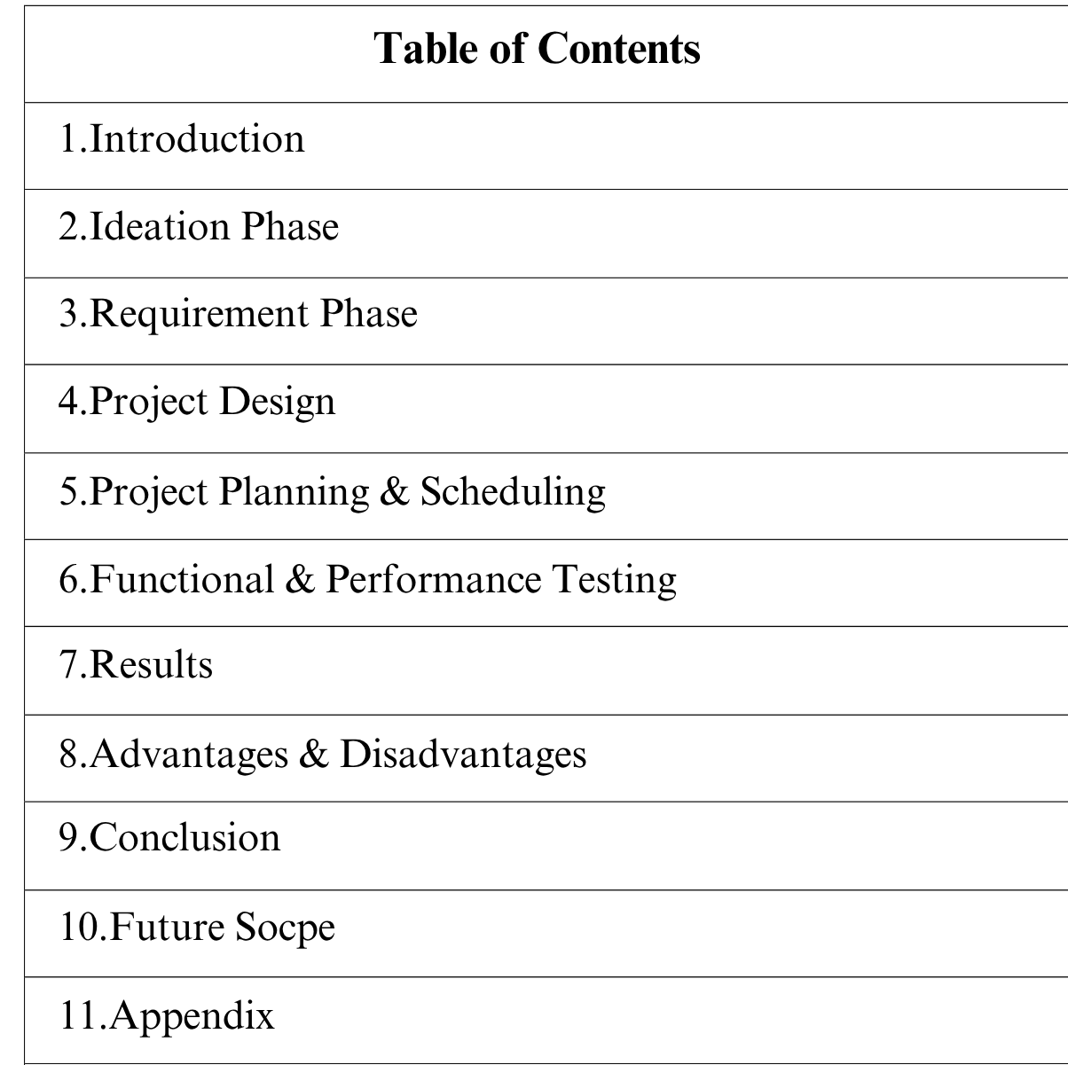

STREAMLINING TICKET ASSIGNMNENT FOR EFFICIENT SUPPORT OPERATIONS

1.INTRODUCTION

1.1 Project Overview
This project, “Streamlining ticket assignment for efficient support operation using ServiceNow” aims to improve support efficiency by automating and streamlining the ticket assignment process through a new or upgrade . Key objectives include centralizing all incoming requests, implementing rules-based automation for assignment, defining clear escalation paths, and using analytics to continuously optimize performance. The project will focus on defining clear goals, configuring the system, training staff, and establishing metrics to monitor success.

1.2 Purpose
The purpose of streamlining ticket assignment is to improve efficiency by ensuring the right agent handles each issue faster, which leads to reduced response and resolution times, balanced workload
- Faster resolution: Matching tickets to agents with the right expertise ensures they are handled more quickly and efficiently, reducing downtime for end-users.
- Increased agent productivity: By automating assignments, support staff spend less time on manual routing and more time on solving problems. This also helps balance workloads so no agent is overwhelmed while another is underutilized.
- Improved organization: A streamlined process centralizes requests, provides a clear workflow.

2. IDEATION PHASE

2.1 Problem statement
Despite utilizing the ServiceNow platform, the current configuration and reliance on manual processes within our ticket assignment workflows are failing to fully leverage the platform's capabilities, resulting in significant operational inefficiencies and a compromised support experience.

2.2 Empathy Map Canvas
The Support Agent
Goal: Efficiently receive and resolve tickets that match their skill set, minimizing time spent on administrative overhead.
Situation: Working through a queue of incoming support tickets.
Who are we empathizing with? | Entity: The IT Support Agent (e.g., "Alex, a Tier 1 Service Desk Agent") responsible for initial ticket review and assignment. They are the user of the ticket assignment process.
Goal | To understand the agent's experience and challenges to create a streamlined, efficient, and less frustrating ticket assignment process.
Map Canvas:
A Ticket Assignment Process Map Canvas can be created using a process flow or workflow diagram template. This visual tool helps define the steps, criteria, and responsibilities for efficient ticket routing, which typically involves the following components:

Ticket Assignment Process Map Canvas
Component | Description | Key Elements & Rules
Ticket Ingestion | How tickets enter the system from various channels (email, phone, chat, web form). | Centralized system, multiple input channels, initial data capture.
Initial Triage & The immediate process Data Gathering: Description, affected systems, Categorization of reviewing and priority level, customer details. Tagging: classifying a new ticket. Automatically or manually adding descriptive labels (e.g., "billing," "bug," "hardware issue," "sales").

2.3 Brainstorming

Brainstorming: Streamlining ticket assignment using ServiceNow
Ideas:
- Create clear categories: Segment tickets by issue type (e.g., billing, technical, feature request) and project.
- Use tagging and keywords: Assign tags and keywords to tickets as they are created to help with automatic routing.
- Implement direct assignment rules: Set up rules to assign tickets to specific teams or agents based on the category or keywords.
- Automate based on expertise: Automatically assign tickets to agents based on their skills and areas of expertise.
- Use automated assignment: Employ software with workflows that automatically route tickets based on predefined logic, ensuring efficiency and accuracy.
- Set up automated follow-ups: Use automated replies for tickets that are unresponsive to help agents close them efficiently.
- Define support tiers: Create tiers (e.g., Tier 1, Tier 2, Tier 3) for different levels of complexity.
- Assign tickets to the right tier: Route simple tickets to lower-tier agents or self-service resources, and escalate complex issues to senior agents or specialized teams.
Develop clear escalation paths: Define who a ticket should be escalated to, ensuring it gets to the right person for higher-level intervention.
- Prioritize tickets: Grade and prioritize tickets based on urgency and impact. Urgent issues should be flagged for immediate attention.
- Define SLAs: Establish clear Service Level Agreements (SLAs) to set customer expectations for response and resolution times.
- Provide training: Ensure support staff have the necessary training to handle their assigned tickets effectively.
- Empower agents: Give agents the tools and autonomy to resolve issues and collaborate with colleagues.
Questions:
1.How are incidents currently categorized and prioritized (e.g., using impact and urgency matrix?
2.How are tickets currently assigned?
3.What data quality issues exist in ticket logging that hinder accurate assignment?

3.REQUIREMENT PHASE

3.1 Objective
To design and implement a streamlined, automated ticket assignment process in ServiceNow that enhances operational efficiency, reduces manual effort, and ensures timely resolution by routing incidents or requests to the right team or agent.

Current Challenges
- Tickets are manually assigned or re-assigned multiple times before reaching the correct resolver group.
- Delays in ticket triage and assignment lead to SLA breaches.
- Lack of visibility into workload distribution across teams.

Goals and Expected Outcomes
- Automate ticket assignment using defined business rules, skill-based routing, and workload balancing.
- Improve first-time-right assignment percentage.
- Reduce mean time to assign (MTTA) and overall incident resolution time.

Scope
In Scope:

Incident and Service Request assignment automation.
- Configuration of assignment rules and workflows in ServiceNow.
Out of Scope:
- Major Incident management processes.
- External integrations (unless directly related to assignment logic).

Stakeholders
- Service Desk Team – primary users and beneficiaries.
- IT Operations Managers – oversight and monitoring.
- Process Owners – Incident/Request process governance.
- ServiceNow Administrator / Developer – configuration and customization.

Success Metrics
- ≥90% of tickets correctly assigned on first attempt.
- ≥30% reduction in mean time to assign (MTTA).
3.2 Solution Requirements:
Functional Requirements:
- Assignment Rules: The system must use predefined assignment rules to automatically route new tickets to the correct support group or individual based on ticket attributes (e.g., category, subcategory, impact, urgency, location).
- Skills-Based Routing: The ability to route tickets to agents with specific skills required for resolution, ensuring the right expertise is engaged from the start.
- Load Balancing (Round-Robin): The system should distribute incoming tickets evenly among available agents within a group to prevent overload and ensure a balanced workload.
NonFunctional Requirements:
- Response Time: The system must assign a newly created ticket to the appropriate group or user within a specified time frame (e.g., less than 1 second of the ticket being submitted) to ensure there are no delays in the support process.
- Throughput: The assignment rules engine must be able to handle a specified volume of concurrent ticket submissions (e.g., 1,000 tickets per hour during peak times) without performance degradation.
- Efficiency: Automated assignment should minimize resource utilization (CPU, memory) to avoid impacting other ServiceNow operations.
Technical Requirements:
- Configure custom tables and categories: Create custom tables to organize and categorize tickets effectively, which provides a basis for routing rules.
Define user roles and groups: Set up roles and groups within ServiceNow to manage access and determine which users or teams can be assigned tickets.
- Establish ACLs: Implement Access Control Lists (ACLs) to ensure data protection and enforce rolebased access to tickets.
3.3 Flow Diagram:
[User]
↓
(P1) Ticket Submission → (D1) Ticket DB
↓
(P2) Classification ↔ (D3) Rules DB
↓
(P3) Assignment Logic ↔ (D2) Agent DB
↓
(P4) Notification & Tracking → [Support Agent]
↘
[Admin]
3.4 Technology Stack

Platform: ServiceNow
Language: JavaScript (for scripting)
Tools:Update SetsFlow, Designers, ScriptDebugger,Access control lists

4.PROJECT DESIGN
4.1 Project Solution kit

Layer Tool

Core Platform ServiceNow ITSM (Incident & Request Management)

Automation Flow Designer, Assignment Rules, Business Rules

Intelligence Predictive Intelligence (ML-based assignment)

4.2 Proposed Solution
A proposed solution for Streamlining ticket assignment in ServiceNow involves automating ticket routing with rules, using Flow Designerfor no-code automation, and integrating with other tools to ensure seamless data flow. Additionally, leveraging ServiceNow's reporting and dashboards for performance insights, customizing workflows to match specific organizational processes, and providing thorough training to staff on best practices are crucial steps for maximizing efficiency.
Benefits of Proposed Solutions:
- Increased Efficiency and Productivity: Automating the routing of tickets frees up IT staff from manual sorting, allowing them to focus on resolving complex issues.
- Faster Resolution Times (MTTR): Tickets are sent to the correct team or individual immediately, reducing delays in response and resolution times.
- Improved Accuracy: Automated rules and machine learning minimize human errors in assignment, ensuring issues land in the right hands the first time and reducing ticket bouncing (reassignment between groups).
- Better Resource Utilization: Tickets are assigned based on factors like agent skillset, availability, and current workload, preventing backlogs and ensuring a balanced distribution of work.

4.3 Solution Architecture
- Setting up ServiceNow Instances
- Creating a User
- Creating a Groups
- Creating a Roles
- Assigning role & users to group
- Assigning role to table
- Creating ACL
*Creation a Flow
*Conclusion
5. PROJECT PLANNING &SCHEDULING

PHASE ESTIMATED TIME
Setting up ServiceNow Instance 1 hour
Creating a User 30 min
Creating a Groups 30 min
Creating a Roles 2 hour
Assigning role & users to group 1.5 hour
Assigning role to table 2 hour
Creating ACL 1 hour

Creation a Flow 30 min
Final Testing & conclusion 1hour

6.FUNCTIONAL AND PERFORMANCE TESTING

6.1PerformanceTesting
- Measure Efficiency and Speed under Load
- Ensure Scalability and Stability
- Identify and Eliminate Bottlenecks
- Use Results for Continuous Improvement

7.RESULTS

7.1 Output Screenshots
- Setting up ServiceNow Instances
- Creating a User
- Creating a Groups
- Creating a Roles
- Assigning role & users to group
- Assigning role to table
- Creating ACL
*Creation a Flow
- Conclusion

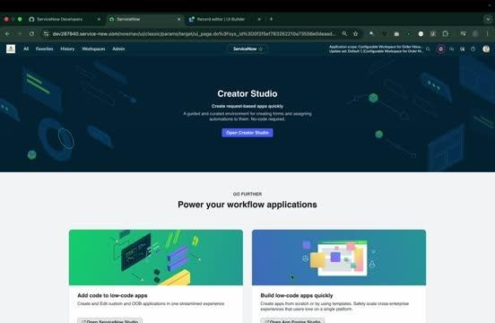

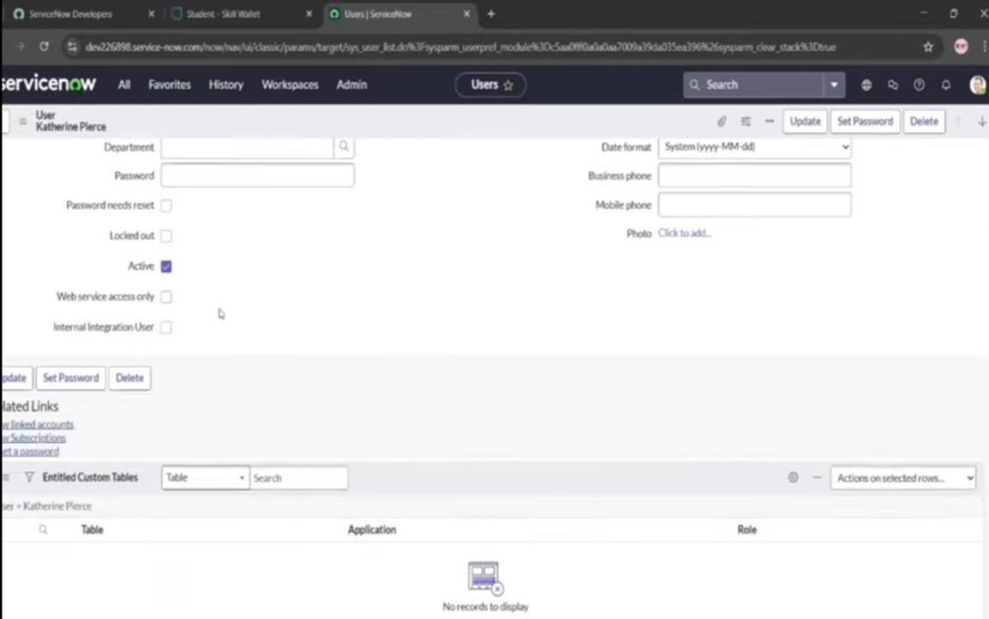

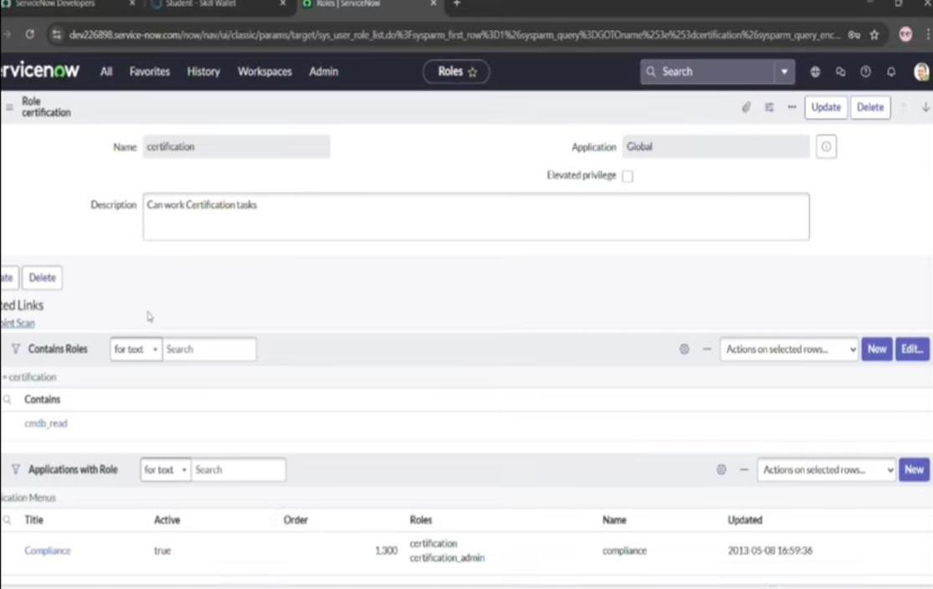

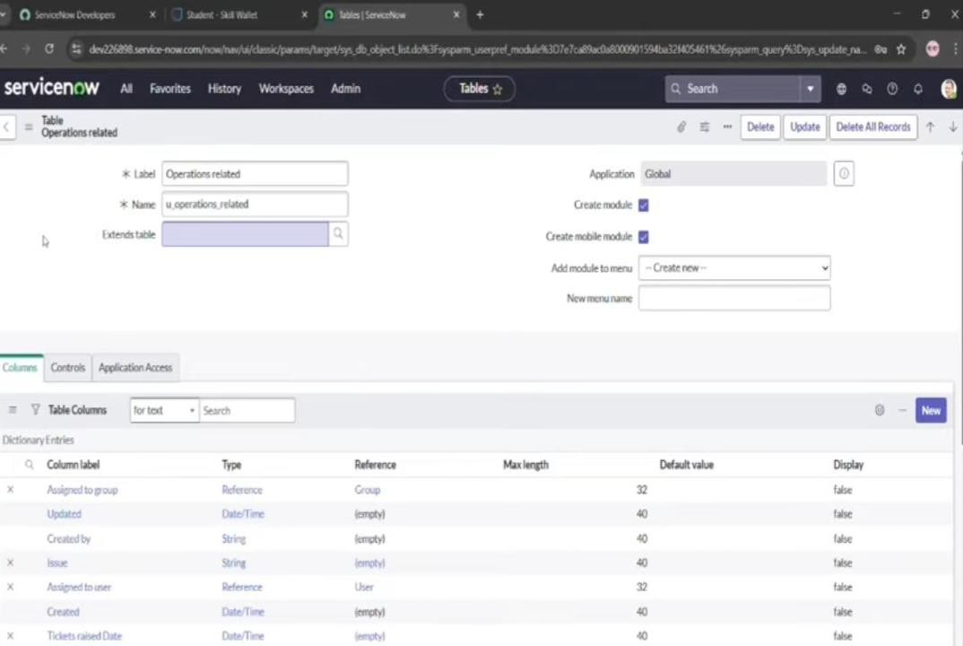

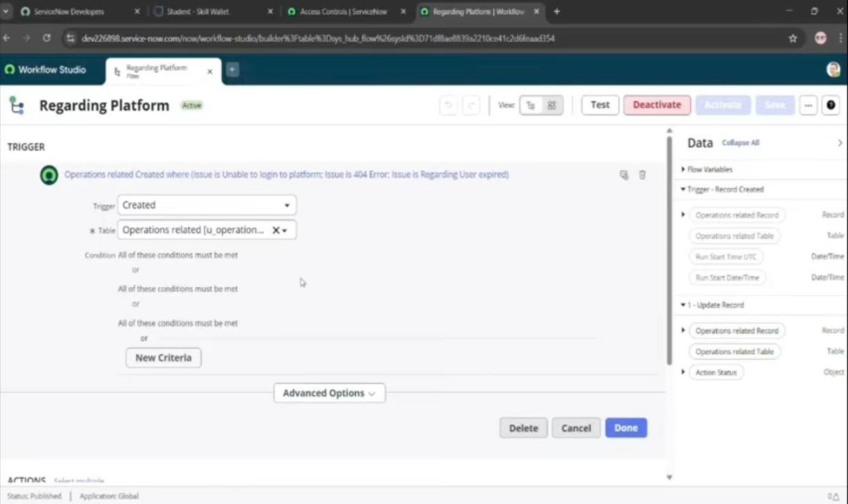

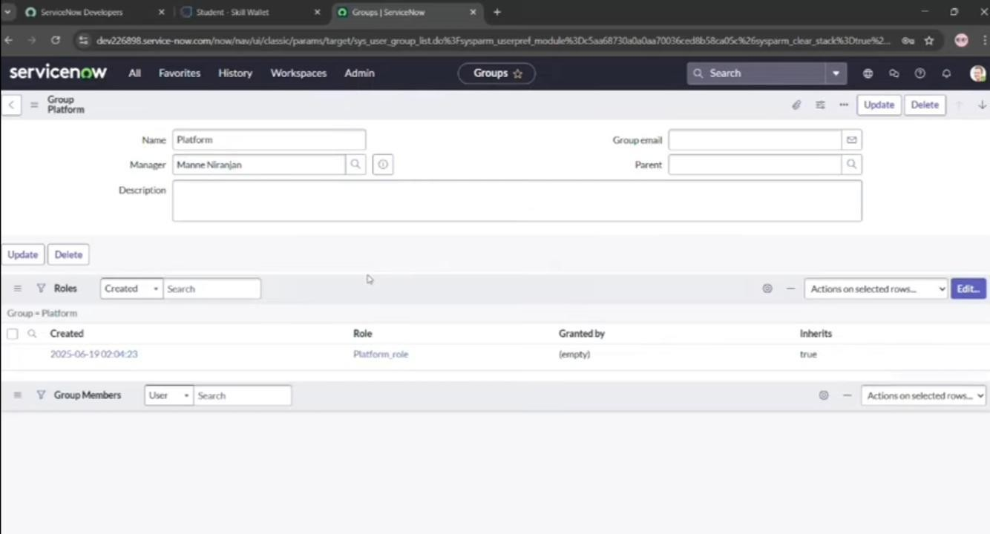

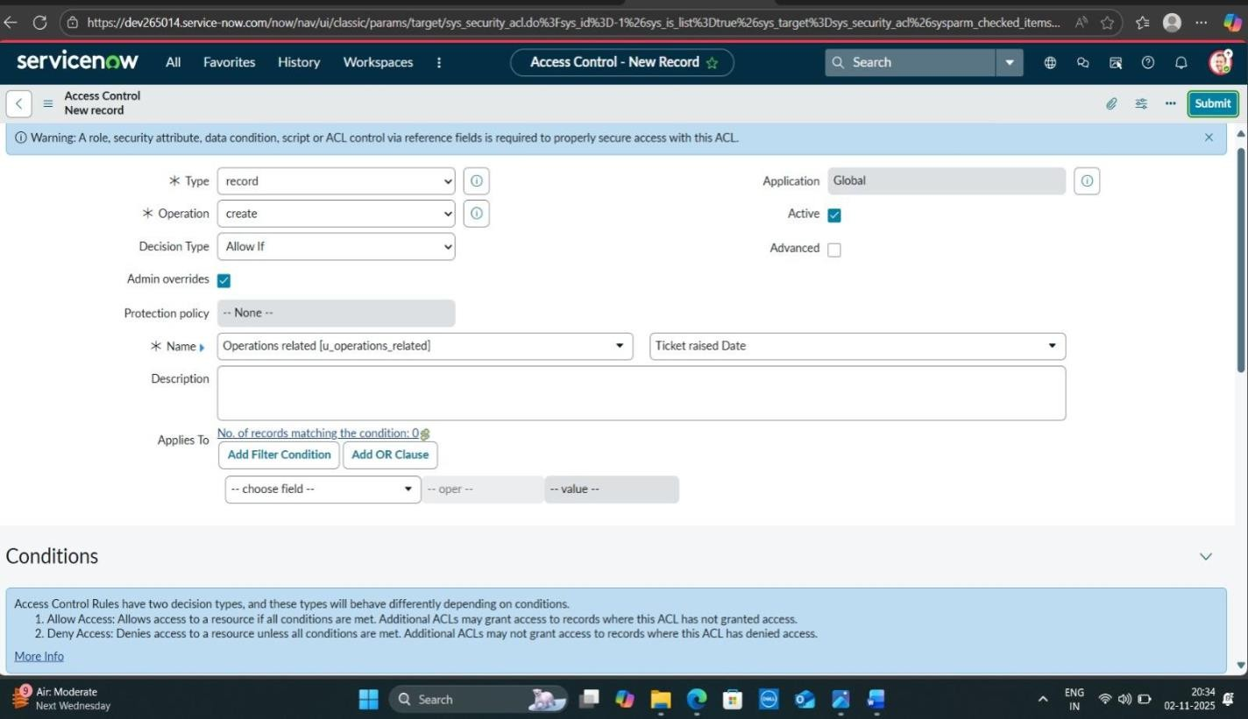

8.ADVANTAGES AND DISADVANTAGES
Advantages:
- Improved Efficiency and Speed: Automation eliminates manual sorting and assignment, leading to instant routing, quicker first responses, and faster overall resolution times.
- Error Reduction: Automated systems ensure tickets are assigned based on predefined rules (e.g., agent skills, availability, workload) without human error, preventing miscategorization and misassignment.
- Enhanced Customer Satisfaction: Faster, more accurate resolutions and consistent communication across centralized platforms improve the customer experience and build trust.
- Increased Agent Productivity and Focus: Agents spend less time on administrative tasks and more time on solving complex issues that require human expertise, reducing the risk of burnout.
- Better Workload Management: Streamlining ensures fair and balanced distribution of tickets among team members, preventing any single agent from becoming overburdened.
- Scalability: Streamlined, often automated, processes can handle increased ticket volumes as a business grows without necessarily needing a proportional increase in staff.
- Data-Driven Insights: Centralized systems provide robust analytics and reports on ticket patterns, agent performance, and bottlenecks, enabling continuous process improvement and informed decision-making.
Disadvantages:
- Lack of Personalization: Overly rigid or automated systems may treat customers as "case numbers" rather than individuals, which can reduce customer satisfaction for those expecting a human touch.
- Potential for Technical Issues: Full reliance on technology means server crashes, software glitches, or internet failures can disrupt the entire support operation, potentially during peak periods.
- Setup and Maintenance Costs: Implementing and continuously refining a sophisticated, automated system can have upfront costs and require ongoing review and updates to assignment rules as business needs change.
- Limited Accessibility for Some Users: Some users, particularly those who are not tech-savvy or lack internet access, may find digital-only or highly streamlined self-service options difficult to use.
- Integration Challenges: If the system is not compatible with other tools used by the organization, agents may have to manually transfer data between platforms, leading to new inefficiencies and potential errors.
- Difficulty with Complex or Unique Issues: Standard rule-based systems may struggle with complex or unique requests that require nuanced human judgment and frequent inter-departmental collaboration, potentially requiring additional triage by human agents.

9.CONCLUSION
In conclusion,Streamlining ticket assignment, particularly through the use of automated or AI-powered systems, fundamentally transforms support operations, leading to significant improvements in efficiency, accuracy, and overall customer satisfaction.
10.FUTURE SCOPE
The future scope of streamlining ticket assignment is centred on advanced automation and the integration of emerging technologies, primarily Artificial Intelligence (AI), Machine Learning (ML), and Generative AI. These technologies are transforming manual, error-prone processes into intelligent, proactive, and highly efficient workflows that improve both agent productivity and the customer experience.
11.APPENDIX
- Source code: No source code; used ServiceNow platform
- Dataset Link: Not Applicable
- GitHub &Project Demo:https://github.com/srinidhik223-hash/STREAMLINING-TICKET-ASSIGNMENT-FOR-EFFICIENT-SUPPORT-OPERATIONS.git

